**FALCON SPIRIT 21.7.2021**

**Background**

Single CTD cast with bottle collection and multiple MSS casts made in vicinity of L4 buoy, roughly halfway between Plymouth and Eddystone Rocks, 50.25 N, 4.22 W.

**CTD results**

Ignore data collected on ascent of CTD as it does not ascend at a sufficiently slow rate. Salinity profile shows two large fresh spikes at ~7 and ~11 dbar (roughly equivalent to depth in metres), likely related to riverine inputs. Temperature profile jumps to lower temperatures between ~37 – 43 dbar. Could this be related to the smaller fresh spike at 40 dbar (i.e., presence of a certain water mass?)

Calculating the salinity- and temperature-controlled components of the Brunt–Väisälä frequency (BVF) shows a dominant control of temperature, as expected in most regions.

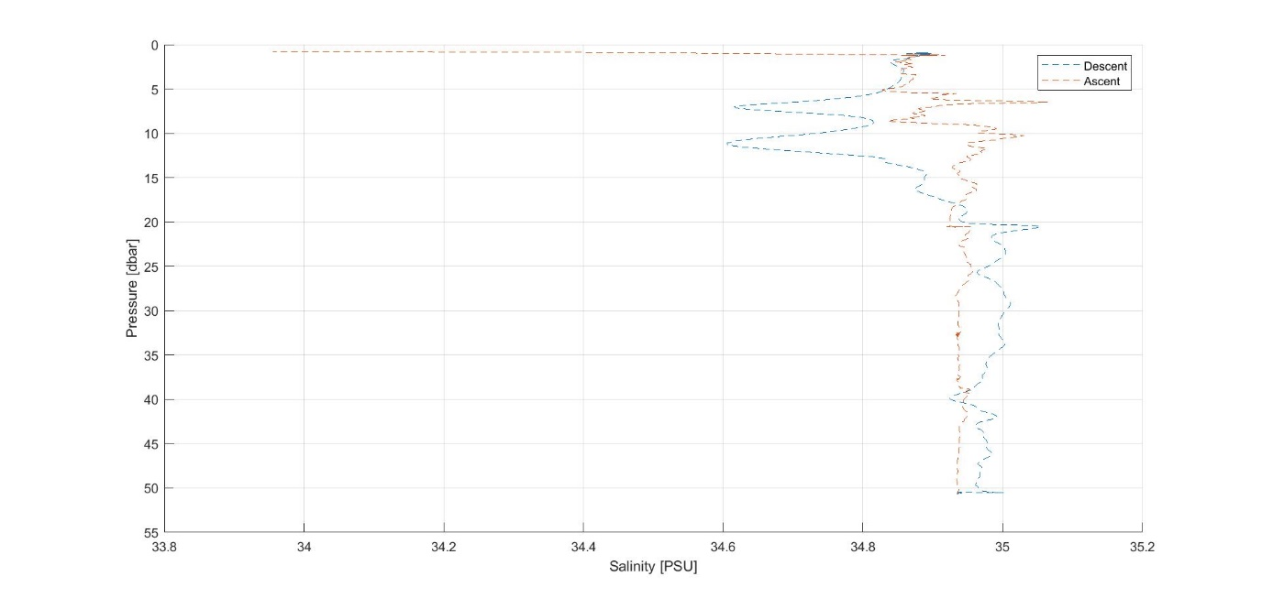

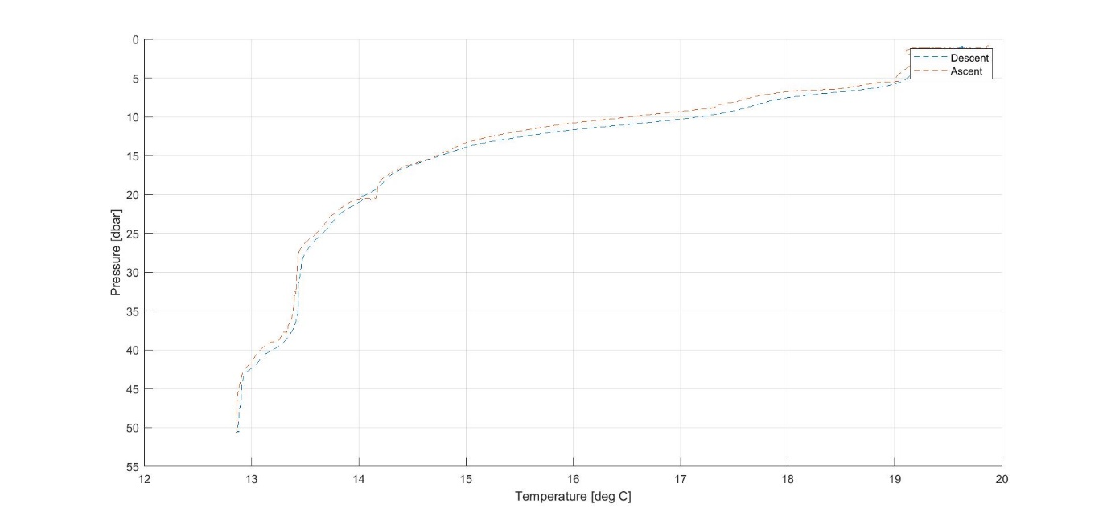

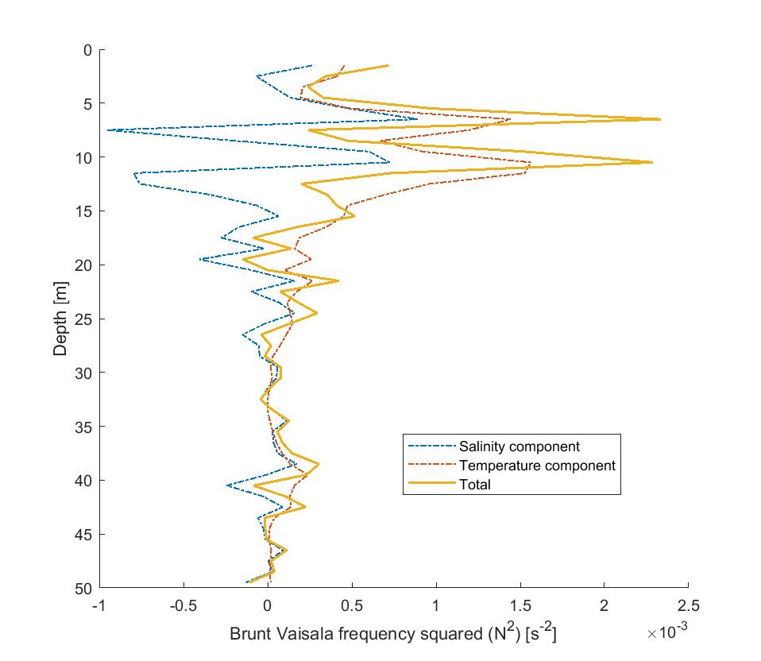

**MSS results**

While more than two MSS casts were made, processing errors were encountered for all but casts 003 and 004.

Salinity profile compares poorly with that from the CTD – possibility of long-term distilled water bath for MSS conductivity probe suggested.

Temperature profile contains jumps at ~27 and ~37 dbar; the second of these may be coincident with the large jump in the CTD profile.

Comparisons of BVF calculated via CTD and MSS data show agreement to order of magnitude, but the MSS-derived BVF lacks the two large spikes which are related to the salinity spikes that it does not capture – best to rely on CTD-derived BVF.

Plots also shown for rate of dissipation of turbulent kinetic energy (ε) and unscaled diapycnal diffusivity (ε/N2, where N = BVF; diapycnal diffusivity = Γ0 ε/N2, where Γ0 = mixing efficiency, which varies from 0.05 – 0.7 in marine environments).

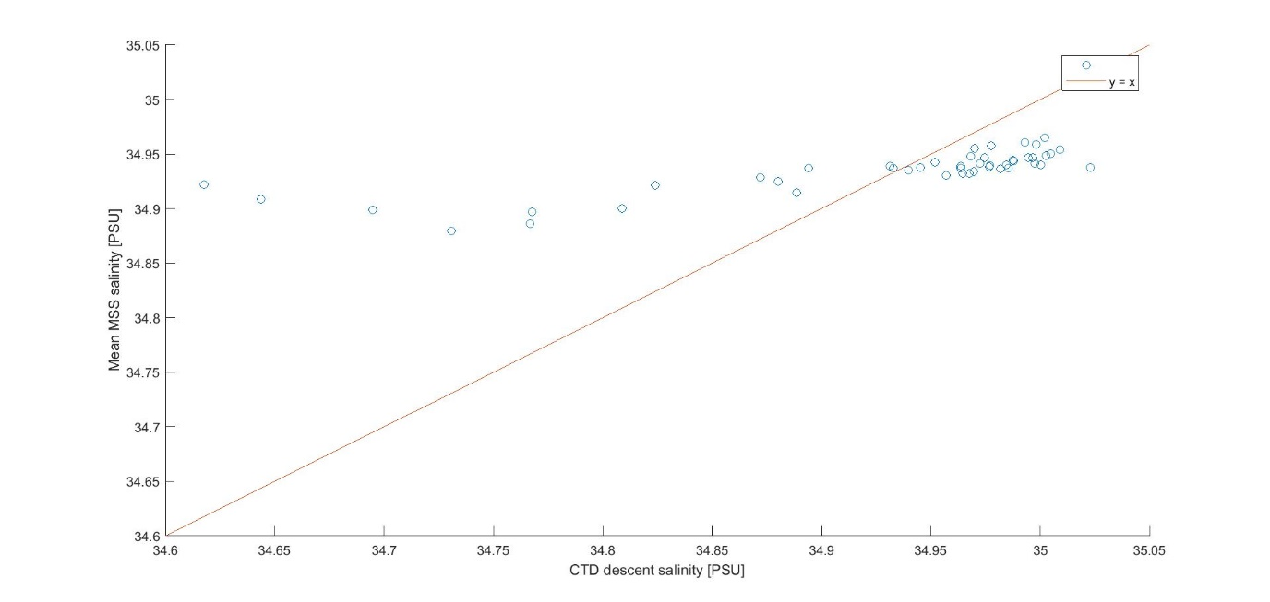

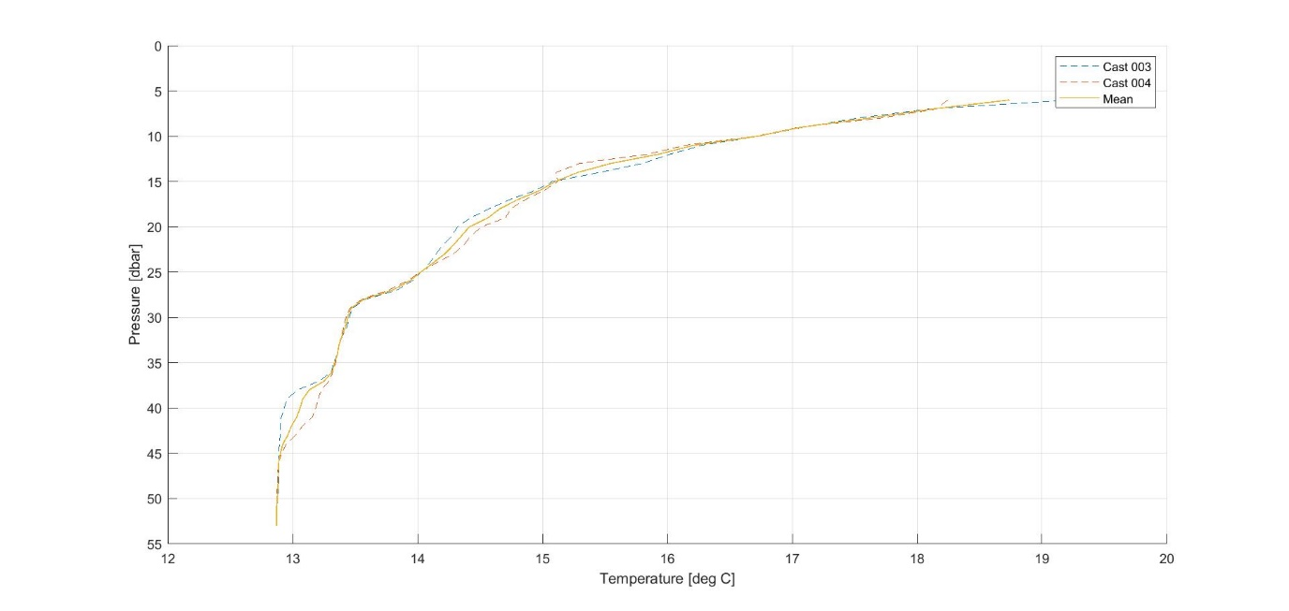

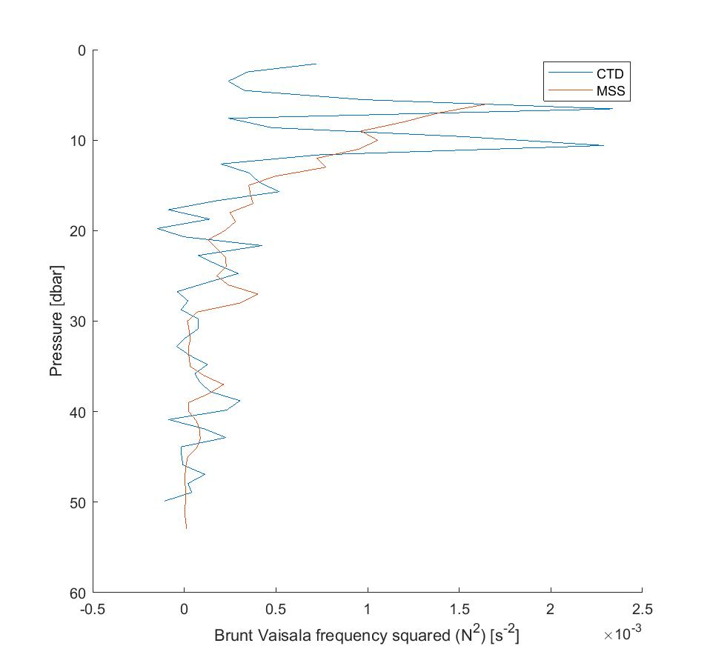

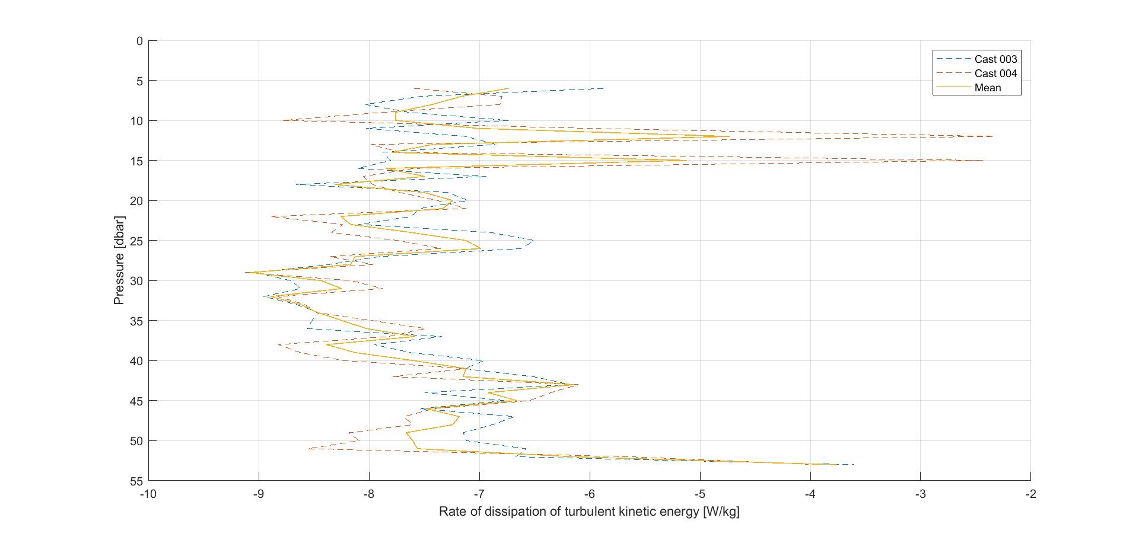

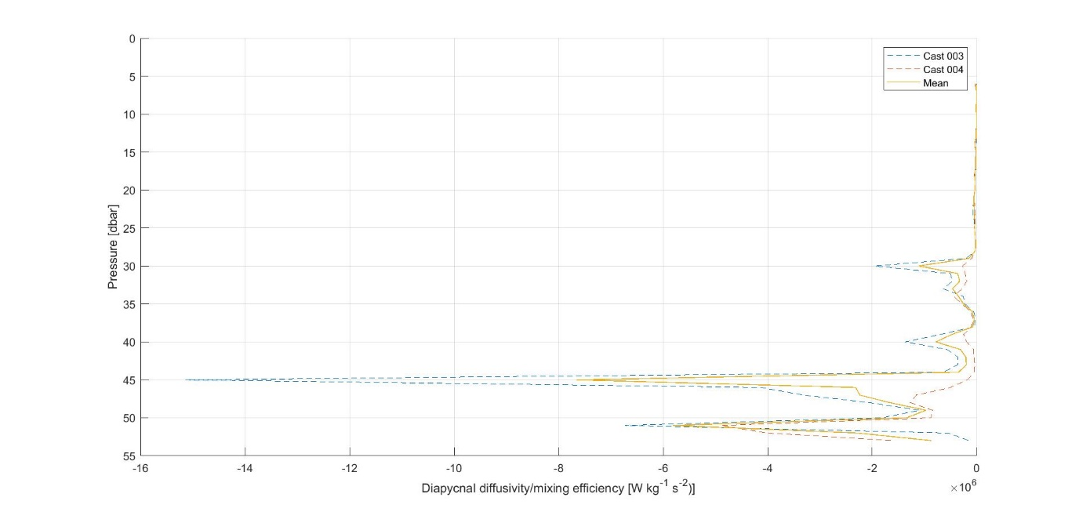

**MSS sensitivity testing**

The following average percentage changes in ε and temperature are seen when changing the value of the shear-temperature sensor offset:

|  |  |  |  |  |
| --- | --- | --- | --- | --- |
| **Change in offset →** | **Halved** | **Doubled** | **Reduced by factor of 10** | **Increased by factor of 10** |
| **Average change in values of ε (%)** | 5.2 x 10-4 | –1.2 x 10-3 | 9.8 x 10-4 | –0.011 |
| **Average change in values of temperature (%)** | 0.033 | –0.065 | 0.059 | –0.62 |

The changes seen in ε are extremely small (well below even 1%) and so ε is not particularly sensitive to changes in this parameter. Temperature is more sensitive, but the changes are still small.

The final step in the “shear_c” batch is three passes of a Butterworth filter to the data from both shear probes and the calculated pseudoshear data. Removing these filters and continuing with processing as normal (the batch “eps+all”, which calculates ε from the shear data, and finally the batch “eddy”) produces very little change in the final values of ε – average percentage change is –1.6 x 10-5.

**Comparison of CTD results with previous results in same location**

A CTD cast at 50.24 N, 4.21 W was made on 10.6.21 (as part of a transect of casts from Plymouth Sound to the Eddystone Reef). Comparisons between the absolute salinity, conservative temperature, and BVF squared are shown below, as well as the BVF squared from June 10 decomposed into temperature and salinity components.

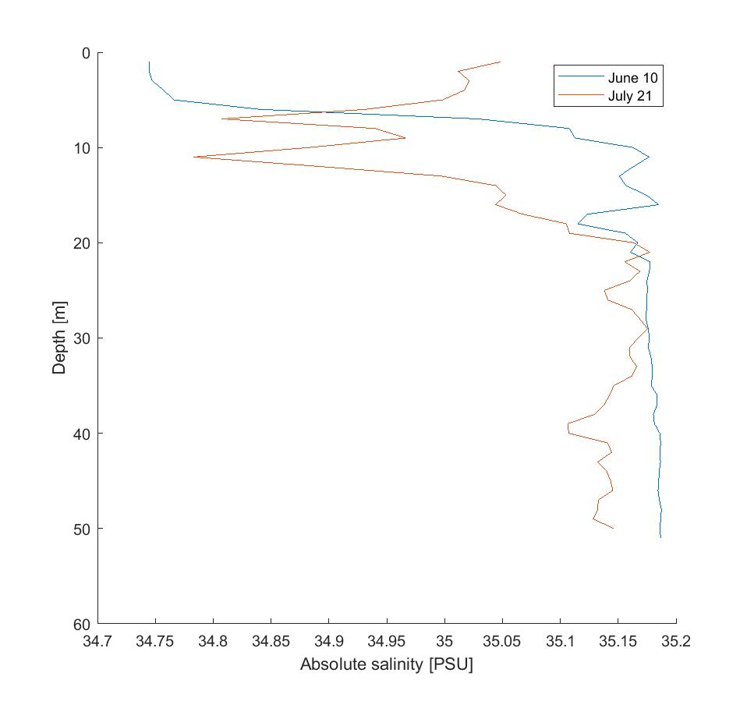

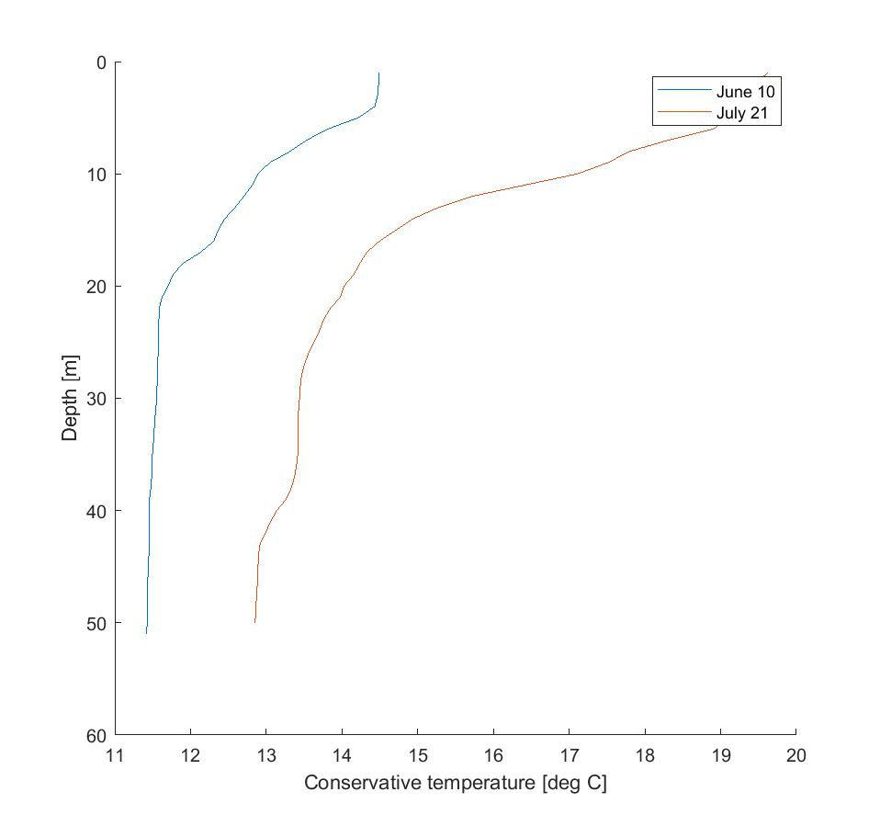

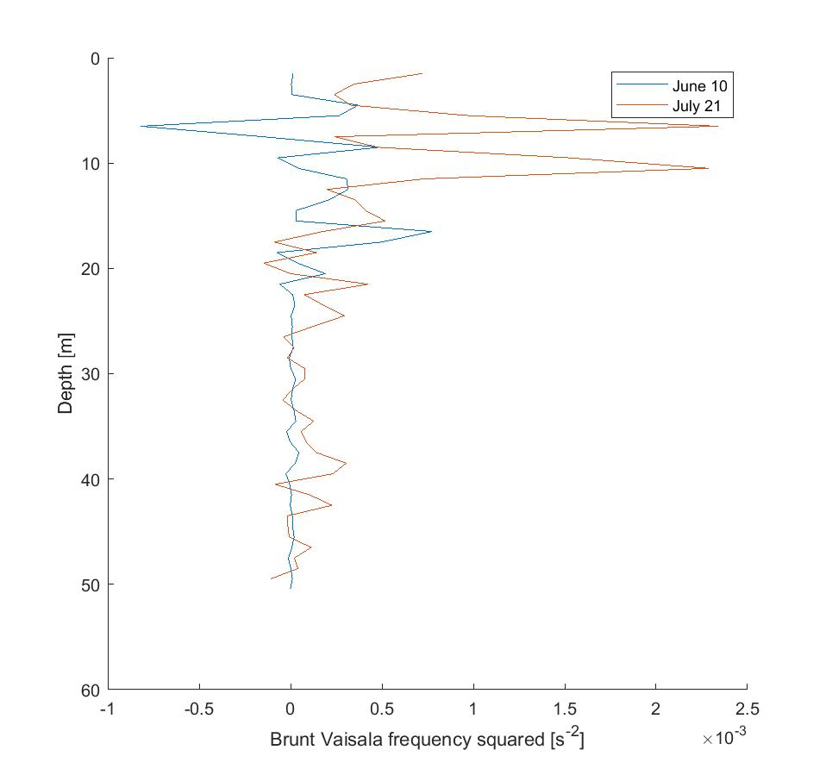

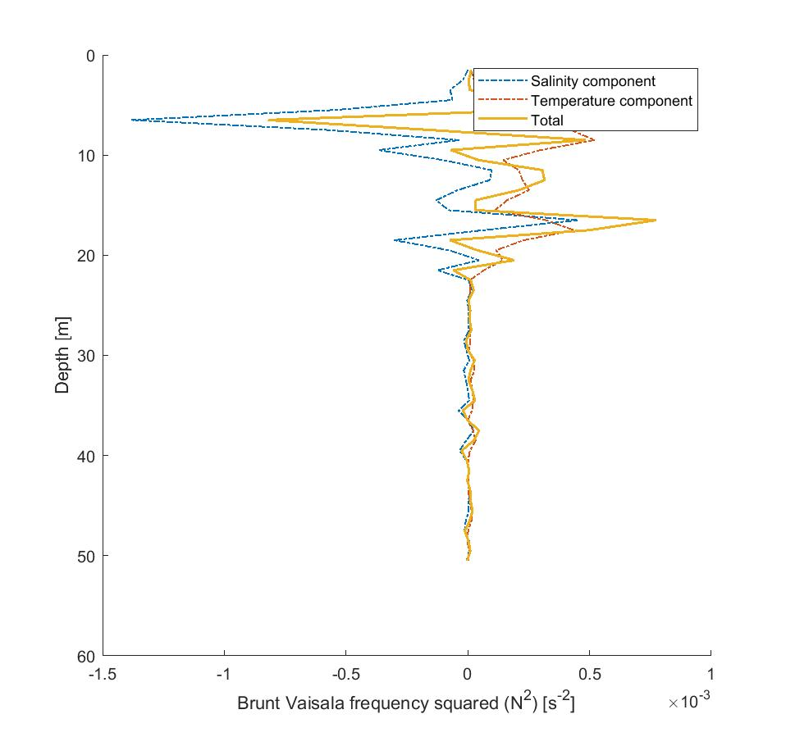

Salinity is consistent with that on July 21 at depth but lacks the freshness seen in the surface ~20 m. Temperature is predictably lower. BVF is also consistent from around 20 m and deeper, but differs at the surface. On July 21, the surface layer BVF appears to be more salinity controlled, but returns to temperature control at depth.

**Comparison of CTD results against transect of previous results**

Below are plots of salinity, temperature, and the components of buoyancy frequency created using MATLAB’s “contourf” and “image” functions, comparing the results collected on 21.7 with the entire transect from 10.6.

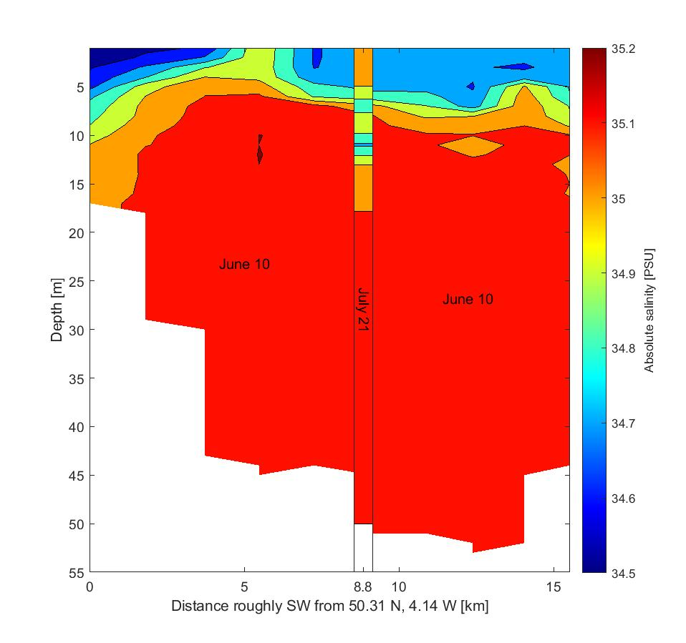

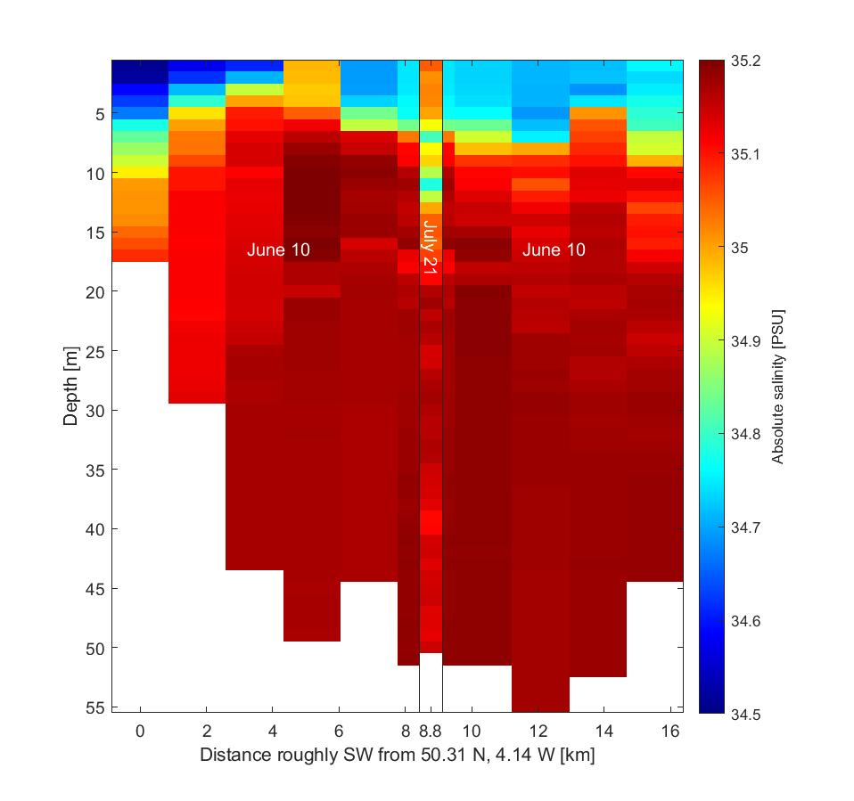

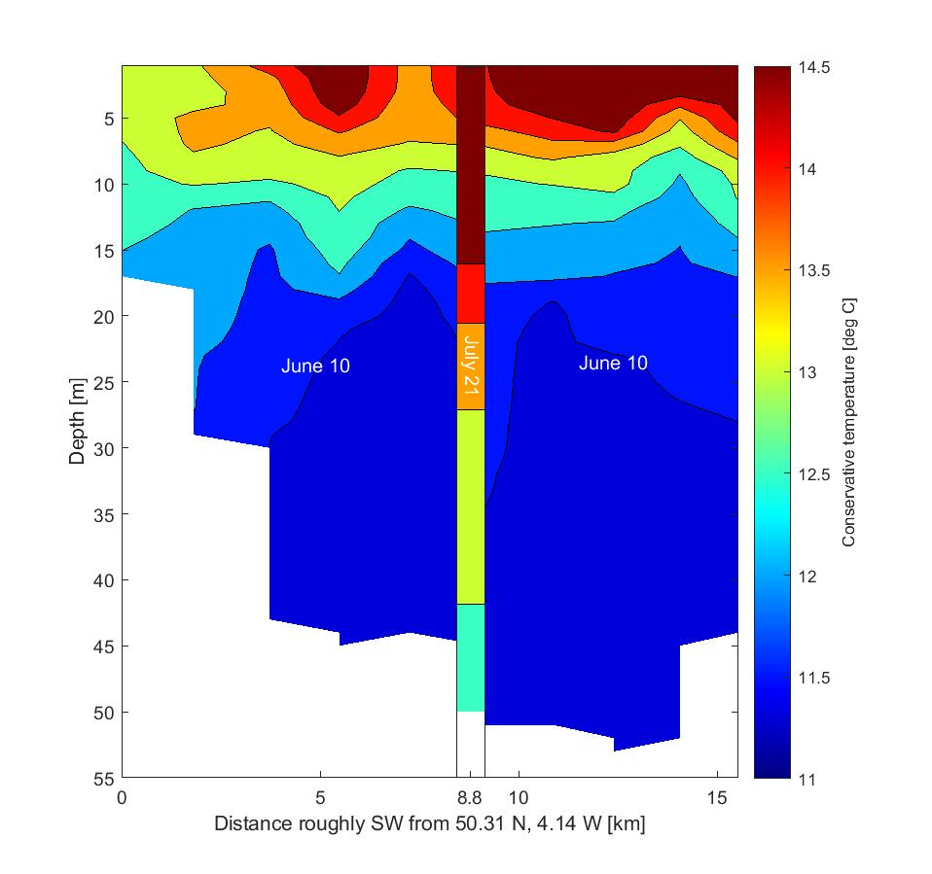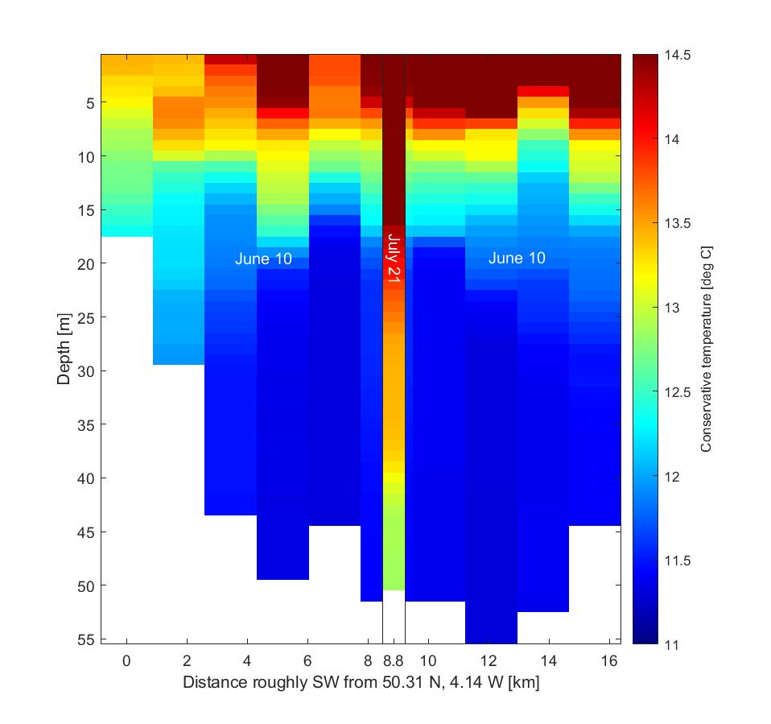

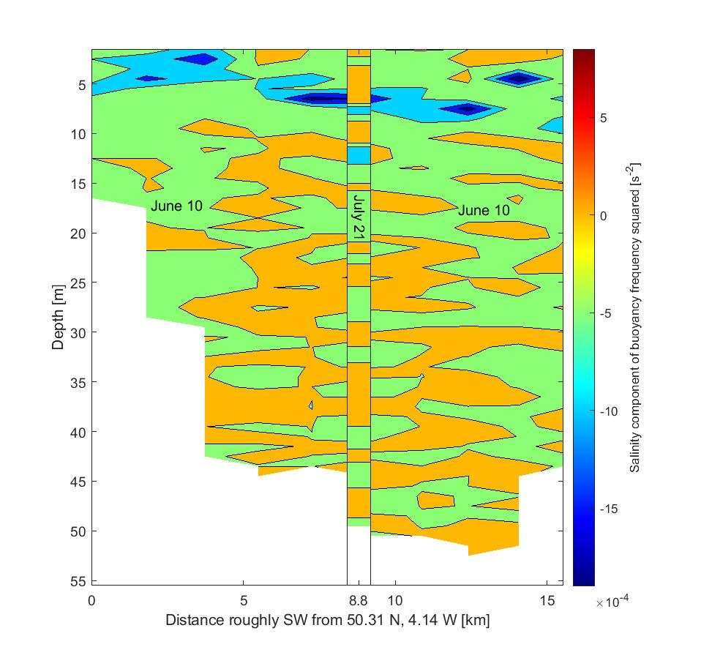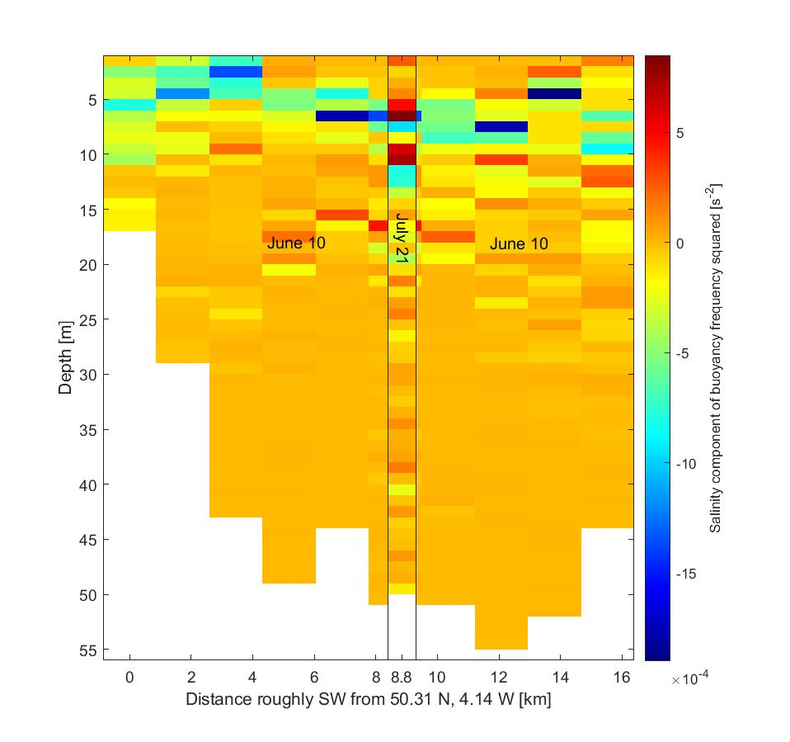

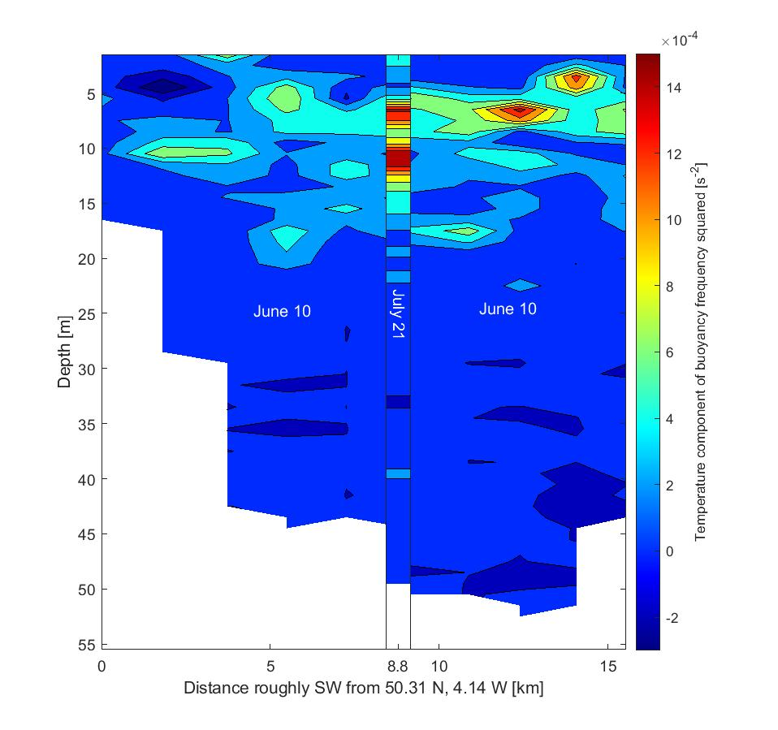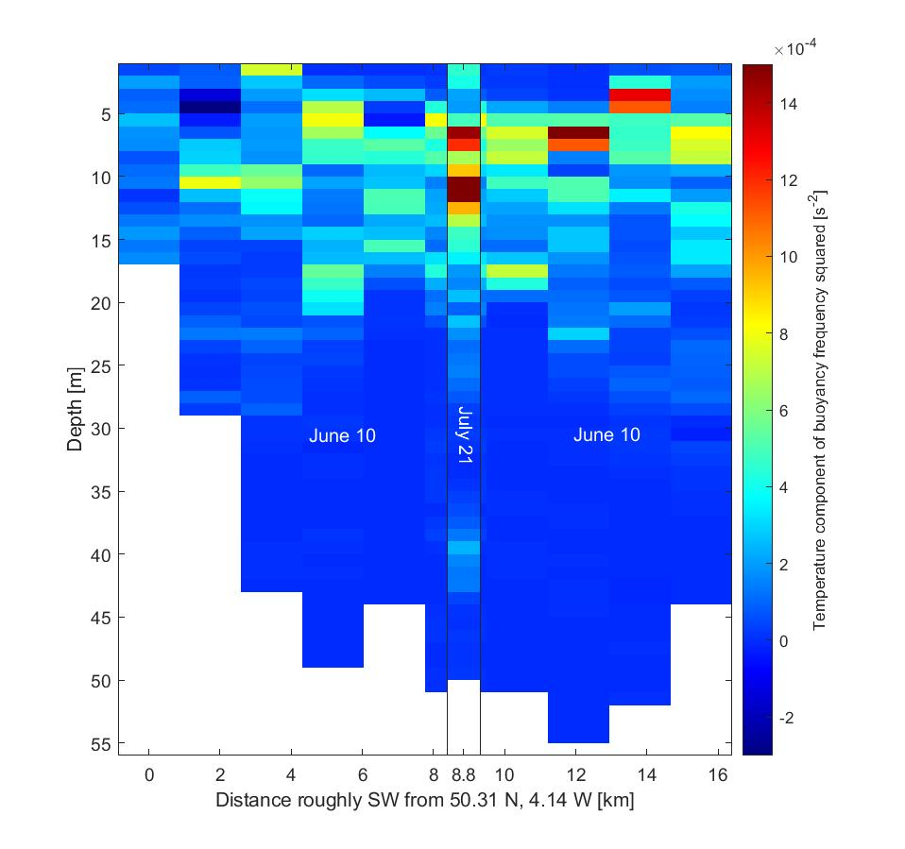

**Plan with anticipated full transect data**

0.5 m bins. CTD profiles of S, T, N2S, N2T, N2 at each station. Also contours or images. Same for things from MSS: ε, Kv (need a mixing efficiency). Copy some of the plots in Ford (2017) also (these relate to chlorophyll data as well).